Table of Contents
S. No. | Description | Page No.
1 | Acknowledgement | 2
2 | Introduction | 3
3 | Objective | 3
4 | Proposed System | 4
5 | Hardware and Software Requirements | 5
6 | Technology Used | 6
7 | Database Used | 11
8 | Source Code | 13
9 | Output | 59
10 | Bibliography | 61

ACKNOWLEDGMENT

I would like to express my special thanks of gratitude to my teacher Mr. Gopal Singh as well as our Principal Mr. Biswajit Dutta who gave me the golden opportunity to do this wonderful project on the topic ' Online Quiz System' which also helped me in doing a lot of research and I came to know about so many new things.
Secondly, I would also like to thank my parents and friends who helped me a lot in finishing this project within the time limit. I am making this project not only for marks but to also increase my knowledge.
I express deep sense of gratitude to almighty God for giving me strength for the successful completion of the project.
I gratefully acknowledge the contribution of the individuals who contributed in bringing this project up to this level, who continues to look after me despite my flaws.
The guidance and support received from all the members who contributed and who are contributing to this project, was vital for the success of the project. I am grateful for their constant support and help.

Student Name
( Omkaar)

Online Quiz System

INTRODUCTION
The Online Quiz system is basically a GUI & CSV-based project done with help of python language. this project is very useful for the School and Colleges to maintain record of student’s regular progress in each subject. This project is multifield project, so that it can be modified for various purposes.

OBJECTIVES OF THE PROJECT
The objective of this project is to let the students apply the programming knowledge into a real- world situation/problem and exposed the students how programming skills helps in developing a good software.
- Write programs utilizing modern software tools.
- Apply object-oriented programming principles effectively when developing small to medium sized projects.
- Write effective procedural code to solve small to medium sized problems.
- Students will demonstrate a breadth of knowledge in computer science, as exemplified in the areas of systems, theory and software development.
Students will demonstrate ability to conduct research or applied Informatics Practices project, requiring writing and presentation skills which exemplify scholarly style in the field of computer science.

PROPOSED SYSTEM

Today one cannot afford to rely on the fallible human beings of be really wants to stand against today’s merciless competition where not to wise saying “to err is human” no longer valid, it’s outdated to rationalize your mistake. So, to keep pace with time, to bring about the best result without malfunctioning and greater efficiency so to replace the unending heaps of flies with a much-sophisticated hard disk of the computer.

One has to use the data management software. Software has been an ascent in atomization various organisations. Many software products working are now in markets, which have helped in making the organizations work easier and efficiently. Data management initially had to maintain a lot of ledgers and a lot of paper work has to be done but now software product on this organization has made their work faster and easier. Now only this software has to be loaded on the computer and work can be done.

This prevents a lot of time and money. The work becomes fully automated and any information regarding the organization can be obtained by clicking the button. Moreover, now it’s an age of computers of and automating such an organization gives the better look.

HARDWARE AND SOFTWARE REQUIREMENTS

I. OPERATING SYSTEM : WINDOWS 10 AND ABOVE
II. PROCESSOR : PENTIUM DUAL CORE OR ABOVE
ATHALON (3800+- 4200+ DUAL CORE)
III. MOTHERBOARD : 1.845 OR 915,995 FOR PENTIUM 0R MSI
K9MM-V VIA K8M800+8237R PLUS CHIPSET FOR AMD ATHALON
IV. PROGRAMMING LANGUAGE : PYTHON 3.3.7 OR ABOVE
V. DATABASE : MySQL 5.5.27 OR ABOVE

TECHNOLOGY USED

Python
Python is a high-level, general-purpose programming language. Its design philosophy emphasizes code readability with the use of significant indentation.
Python is dynamically-typed and garbage-collected. It supports multiple programming paradigms, including structured (particularly procedural), object-oriented and functional programming.

Guido van Rossum began working on Python in the late 1980s as a successor to the ABC programming language and first released it in 1991 as Python 0.9.0.
Python 2.0 was released in 2000 and introduced new features such as list comprehensions, cycle-detecting garbage collection, reference counting, and Unicode support. Python 3.0, released in 2008, was a major revision that is not completely backward-compatible with earlier versions. Python 2 was discontinued with version 2.7.18 in 2020.
Python is an interpreted, object-oriented, high-level programming language with dynamic semantics. Its high-level built-in data structures, combined with dynamic typing and dynamic binding, make it very attractive for Rapid Application Development, as well as for use as a scripting or glue language to connect existing components together. Python's simple, easy to learn syntax emphasizes readability and therefore reduces the cost of program maintenance. Python supports modules and packages, which encourages program modularity and code reuse. The Python interpreter and the extensive standard library are available in source or binary form without charge for all major platforms, and can be freely distributed.
Python is used for:
- web development (server-side),
- software development,
- mathematics,
- system scripting.
What can Python do?
- Python can be used on a server to create web applications.
- Python can be used alongside software to create workflows.
- Python can connect to database systems. It can also read and modify files.
- Python can be used to handle big data and perform complex mathematics.
- Python can be used for rapid prototyping, or for production-ready software development.
Why Python?
- Python works on different platforms (Windows, Mac, Linux, Raspberry Pi, etc).
- Python has a simple syntax similar to the English language.
- Python has syntax that allows developers to write programs with fewer lines than some other programming languages.
- Python runs on an interpreter system, meaning that code can be executed as soon as it is written. This means that prototyping can be very quick.
- Python can be treated in a procedural way, an object-oriented way or a functional way.
It is possible to write Python in an Integrated Development Environment, such as Thonny, Pycharm, Netbeans or Eclipse which are particularly useful when managing larger collections of Python files.
Python Syntax compared to other programming languages
- Python was designed for readability, and has some similarities to the English language with influence from mathematics.
- Python uses new lines to complete a command, as opposed to other programming languages which often use semicolons or parentheses.
- Python relies on indentation, using whitespace, to define scope; such as the scope of loops, functions and classes. Other programming languages often use curly-brackets for this purpose.

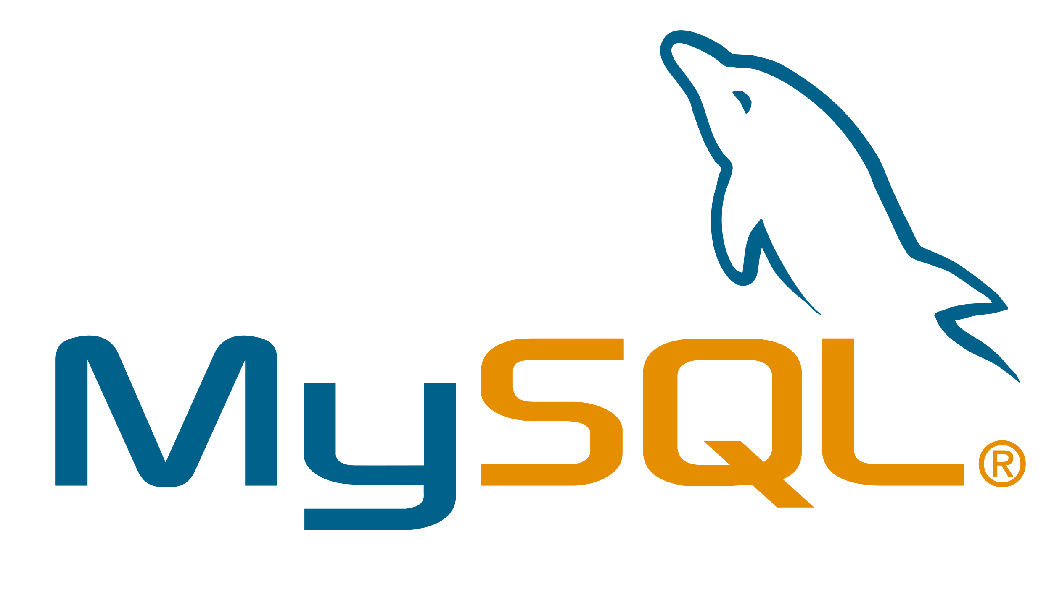
MySQL
MySQL, the most popular Open Source SQL database management system, is developed, distributed, and supported by Oracle Corporation.
The MySQL website (http://www.mysql.com/) provides the latest information about MySQL software.
MySQL is a database management system.
A database is a structured collection of data. It may be anything from a simple shopping list to a picture gallery or the vast amounts of information in a corporate network. To add, access, and process data stored in a computer database, you need a database management system such as MySQL Server. Since computers are very good at handling large amounts of data, database management systems play a central role in computing, as standalone utilities, or as parts of other applications.

MySQL databases are relational.
A relational database stores data in separate tables rather than putting all the data in one big storeroom. The database structures are organized into physical files optimized for speed. The logical model, with objects such as databases, tables, views, rows, and columns, offers a flexible programming environment. You set up rules governing the relationships between different data fields, such as one-to-one, one-to-many, unique, required or optional, and “pointers” between different tables. The database enforces these rules, so that with a well-designed database, your application never sees inconsistent, duplicate, orphan, out-of-date, or missing data.

The SQL part of “MySQL” stands for “Structured Query Language”. SQL is the most common standardized language used to access databases. Depending on your programming environment, you might enter SQL directly (for example, to generate reports), embed SQL statements into code written in another language, or use a language-specific API that hides the SQL syntax.
SQL is defined by the ANSI/ISO SQL Standard. The SQL standard has been evolving since 1986 and several versions exist. In this manual, “SQL-92” refers to the standard released in 1992, “SQL:1999” refers to the standard released in 1999, and “SQL:2003” refers to the current version of the standard. We use the phrase “the SQL standard” to mean the current version of the SQL Standard at any time.

MySQL software is Open Source.
Open Source means that it is possible for anyone to use and modify the software. Anybody can download the MySQL software from the Internet and use it without paying anything. If you wish, you may study the source code and change it to suit your needs. The MySQL software uses the GPL (GNU General Public License).

DATABASE USED
Comma Separated Values (C.S.V) File
CSV File Name: users.csv
example of users.csv
username | password
admin | admin@1234
omkaar | 1234
Krishna Bansal | 123456

CSV File Name: user_progress.csv
example of user_progress.csv
Username | Score | Subject
omkaar | 7 | Science
admin | 9 | History
Krishna Bansal | 6 | Current Affairs

CSV File Name: Krishna.csv
example of Krishna.csv
Subject | Question ID | Question | OptionA | OptionB | OptionC | OptionD | Correct Option
General knowledge | GEN01 | What is the capital of France? | Paris | London | Berlin | Madrid | Option A
Science | SCI01 | What is H2O commonly known as? | Salt | Water | Hydrogen | Oxygen | Option B
History | HIS01 | Who was the first president of the United States? | George Washington | Thomas Jefferson | Abraham Lincoln | John Adams | Option A

SOURCE CODE
from tkinter import *
from tkinter import messagebox
import pandas as pd
import matplotlib.pyplot as plt
from PIL import Image,ImageTk

username=NONE

#helping Functions
def get_length(df,sub,user):
id_df=df[(df['Subject']==sub) & (df['Username']==user)]
length=len(id_df)
ls=[j for j in range(1,length+1)]
return ls

def get_subject(df,sub,user):
Scoredf=df[(df['Subject']==sub) & (df['Username']==user)]
Scoredf=Scoredf['Score']

return Scoredf

def get_max(ls, df, user):
results = []
for index in range(len(ls)):
Sub_max = df[(df['Subject'] == ls[index]) & (df['Username'] == user)]
if not Sub_max.empty:
results.append(max(Sub_max['Score']))
else:
results.append(0) # Default score if no matching records
return results

#Chart creating functions
def create_piechart(score):
plt.pie([score,10-score],labels=["Right","Wrong"])
plt.legend()
plt.savefig('Images/piechart')
plt.close()

def create_barchart(quiz_subjects,user_progress_data,username):
sub=["G.K","Science","Maths","History","Geo","Lit.","Tech","Sports","Ent.","Mytho","C.A","Pop Cul."]
plt.barh(sub,get_max(quiz_subjects,user_progress_data,username))
plt.yticks(fontsize=8)
plt.ylabel('Subjects')
plt.xlabel('Maximum Score')
plt.savefig('Images/Barchart')
plt.close()

def create_linechart(subject,user_progress_data,username):
plt.plot(get_length(user_progress_data, subject, username), get_subject(user_progress_data, subject, username), label=subject)
plt.legend()
plt.savefig('Images/LineChart')
plt.close()

#button function & backend
def add_user(): #Signing Up and adding user in respective csv file
global username
username = signup_username_ent.get().strip()
password = signup_password_ent.get().strip()

if not username or not password:
messagebox.showwarning('Fill the fields', 'Please enter both username and password.')
return

if username in user_pass_data['username'].values:
messagebox.showinfo('Username already exists', f"Username '{username}' is already taken. Please choose a different one.")
else:
user_pass_data.loc[len(user_pass_data)] = [username, password]
user_pass_data.to_csv('Data/users.csv', index=False)
signup_username_ent.delete(0, END)
signup_password_ent.delete(0, END)
messagebox.showinfo('Success', 'User registered successfully!')
show_frame(Login)

def login_user(): #Logingin in user
global username
username = login_username_ent.get().strip()
password = login_password_ent.get().strip()

if not username or not password:
messagebox.showwarning('Fill the fields', 'Please enter both username and password.')
return

user_row = user_pass_data[user_pass_data['username'] == username]
if not user_row.empty and user_row.iloc[0]['password'] == password:
messagebox.showinfo('Success', 'Login successful!')
show_frame(Declar)
else:
messagebox.showwarning('login failed','please enter correct username and password')

def increase_qno(): #increasing qustion number
global qno
qno+=1

def Show_Question(id): #Showing question for the first instance
global qno
global globalid
global section_question

globalid = id # Update the global ID for the subject

# Filter questions for the selected subject
section_question = questions_data[questions_data['Subject'] == id].sample(10).reset_index(drop=True)

# Check if `qno` is within valid range
question_text = f"{qno}. {section_question.loc[qno - 1, 'Question']}"
Question_label.configure(text=question_text)

# Update options
opt1.configure(text=section_question.loc[qno - 1, "OptionA"])
opt2.configure(text=section_question.loc[qno - 1, "OptionB"])
opt3.configure(text=section_question.loc[qno - 1, "OptionC"])
opt4.configure(text=section_question.loc[qno - 1, "OptionD"])

def show_Questions_forcont(): #Showing question after first instance
global qno
global section_question

if qno<=len(section_question):
question_text = f"{qno}. {section_question.loc[qno - 1, 'Question']}"
Question_label.configure(text=question_text)

# Update options
opt1.configure(text=section_question.loc[qno - 1, "OptionA"])
opt2.configure(text=section_question.loc[qno - 1, "OptionB"])
opt3.configure(text=section_question.loc[qno - 1, "OptionC"])
opt4.configure(text=section_question.loc[qno - 1, "OptionD"])

opt1.configure(bg='#2eff70')
opt2.configure(bg='#2eff70')
opt3.configure(bg='#2eff70')
opt4.configure(bg='#2eff70')
else:
Progress_recorded()
show_stats()

def check(opt):
global res
global section_question
global score
section_ans=section_question
if opt==section_ans.loc[qno-1,'Correct_Option']:
res=1
else:
res=0

def color_button(p):
if p=='Option A':
opt1.configure(bg='red')
opt2.configure(bg='#2eff70')
opt3.configure(bg='#2eff70')
opt4.configure(bg='#2eff70')
elif p=='Option B':
opt1.configure(bg='#2eff70')
opt2.configure(bg='red')
opt3.configure(bg='#2eff70')
opt4.configure(bg='#2eff70')
elif p=='Option C':
opt1.configure(bg='#2eff70')
opt2.configure(bg='#2eff70')
opt3.configure(bg='red')
opt4.configure(bg='#2eff70')
elif p=='Option D':
opt1.configure(bg='#2eff70')
opt2.configure(bg='#2eff70')
opt3.configure(bg='#2eff70')
opt4.configure(bg='red')

def score_add():
global score
score+=int(res)
score_label.config(text=f"Score: {score}")

def Progress_recorded():
global username, score, globalid, user_progress_data, quiz_subjects
new_row = pd.DataFrame([[username, score, globalid]], columns=["Username", "Score", "Subject"])
user_progress_data = pd.concat([user_progress_data, new_row], ignore_index=True)
user_progress_data.to_csv('Data/user_progress.csv', index=False)
create_piechart(score)
create_barchart(quiz_subjects,user_progress_data,username)

def show_stats(): #Showing Statistics frame
global pie
Stats_label.config(text=f"Congrats {username} for completing this Quiz!!!")
Final_score_label.configure(text=f"Score: {score}")
pie=Image.open('Images/piechart.png')
pie = pie.resize((400, 400))
pie = ImageTk.PhotoImage(pie)
piechart_label.config(image=pie,bg='#E9EDF1')
show_frame(Stats)

def bargraph_show():
global bargraph
bargraph=Image.open('Images/Barchart.png')
bargraph = bargraph.resize((400, 400))
bargraph = ImageTk.PhotoImage(bargraph)
Barchart_Image.config(image=bargraph)

def show_graph(pid):
global username,user_progress_data,Linegraph
create_linechart(pid,user_progress_data,username)
Linegraph=Image.open('Images/LineChart.png')
Linegraph = Linegraph.resize((400, 400))
Linegraph = ImageTk.PhotoImage(Linegraph)
Linegraph_Image.config(image=Linegraph)

def exit():
root.destroy()

def restart():
global qno, score, section_question, res, username, globalid,optname,user_response

# Reset all necessary global variables
qno = 1
score = 0
section_question = None
res = None
globalid = None
optname=None
user_response=pd.DataFrame(columns=['Response'])

# Reset the score label and question display
score_label.config(text=f"Score: {score}")
Question_label.config(text="")

# Reset the options buttons
opt1.config(bg="#2eff70", text="")
opt2.config(bg="#2eff70", text="")
opt3.config(bg="#2eff70", text="")
opt4.config(bg="#2eff70", text="")

# Reset the submit button
submitbtn.config(state=NORMAL)

show_frame(Declar)

def getting_option_name(df,no,str):
txt=df.loc[no,str]
txt=txt.replace(' ','')
option_name=df.loc[no,txt]
return option_name

def option_name(label):
global optname
optname=label

def user_response_name(df,no,str):
txt=df.loc[no-1,str]
return txt

def adding_user_response():
global section_question,user_response,optname,qno
user_response.loc[qno-1]=[user_response_name(section_question,qno,optname)]

def questionplate():
global section_question,user_response
correct_answer_1.configure(text=getting_option_name(section_question,0,'Correct_Option'))
correct_answer_2.configure(text=getting_option_name(section_question,1,'Correct_Option'))
correct_answer_3.configure(text=getting_option_name(section_question,2,'Correct_Option'))
correct_answer_4.configure(text=getting_option_name(section_question,3,'Correct_Option'))
correct_answer_5.configure(text=getting_option_name(section_question,4,'Correct_Option'))
correct_answer_6.configure(text=getting_option_name(section_question,5,'Correct_Option'))
correct_answer_7.configure(text=getting_option_name(section_question,6,'Correct_Option'))
correct_answer_8.configure(text=getting_option_name(section_question,7,'Correct_Option'))
correct_answer_9.configure(text=getting_option_name(section_question,8,'Correct_Option'))
correct_answer_10.configure(text=getting_option_name(section_question,9,'Correct_Option'))

user_answer_1.configure(text=user_response.loc[0,'Response'])
user_answer_2.configure(text=user_response.loc[1,'Response'])
user_answer_3.configure(text=user_response.loc[2,'Response'])
user_answer_4.configure(text=user_response.loc[3,'Response'])
user_answer_5.configure(text=user_response.loc[4,'Response'])
user_answer_6.configure(text=user_response.loc[5,'Response'])
user_answer_7.configure(text=user_response.loc[6,'Response'])
user_answer_8.configure(text=user_response.loc[7,'Response'])
user_answer_9.configure(text=user_response.loc[8,'Response'])
user_answer_10.configure(text=user_response.loc[9,'Response'])

def color_wr():
if user_answer_1.cget('text')==correct_answer_1.cget('text'):
user_answer_1.configure(bg='#54f780')
else:
user_answer_1.configure(bg='#fa6446')

if user_answer_2.cget('text')==correct_answer_2.cget('text'):
user_answer_2.configure(bg='#54f780')
else:
user_answer_2.configure(bg='#fa6446')

if user_answer_3.cget('text')==correct_answer_3.cget('text'):
user_answer_3.configure(bg='#54f780')
else:
user_answer_3.configure(bg='#fa6446')

if user_answer_4.cget('text')==correct_answer_4.cget('text'):
user_answer_4.configure(bg='#54f780')
else:
user_answer_4.configure(bg='#fa6446')

if user_answer_5.cget('text')==correct_answer_5.cget('text'):
user_answer_5.configure(bg='#54f780')
else:
user_answer_5.configure(bg='#fa6446')

if user_answer_6.cget('text')==correct_answer_6.cget('text'):
user_answer_6.configure(bg='#54f780')
else:
user_answer_6.configure(bg='#fa6446')

if user_answer_7.cget('text')==correct_answer_7.cget('text'):
user_answer_7.configure(bg='#54f780')
else:
user_answer_7.configure(bg='#fa6446')

if user_answer_8.cget('text')==correct_answer_8.cget('text'):
user_answer_8.configure(bg='#54f780')
else:
user_answer_8.configure(bg='#fa6446')

if user_answer_9.cget('text')==correct_answer_9.cget('text'):
user_answer_9.configure(bg='#54f780')
else:
user_answer_9.configure(bg='#fa6446')

if user_answer_10.cget('text')==correct_answer_10.cget('text'):
user_answer_10.configure(bg='#54f780')
else:
user_answer_10.configure(bg='#fa6446')

def boo():
global ch
ch=1

def check_none(choice_flag):
if choice_flag == 0: # No option selected
messagebox.showwarning("No Option Selected", "Please choose an option before submitting.")
return False # Stop execution
return True # Proceed

def restart_characterflag():
global ch
ch=0

user_pass_data=pd.read_csv('Data/users.csv')
questions_data=pd.read_csv('Data/krishna.csv')
user_progress_data=pd.read_csv('Data/user_progress.csv')
# List of subjects for the quiz
quiz_subjects = [
"General Knowledge",
"Science",
"Mathematics",
"History",
"Geography",
"Literature",
"Technology",
"Sports",
"Entertainment",
"Mythology",
"Current Affairs",
"Pop Culture"
]

qno=1
globalid=NONE
score=0
section_question=NONE
res=NONE
user_response=pd.DataFrame(columns=['Response'])
optname=None
ch=0

pie=None
bar=None
line=None

fon="vendana"
root = Tk()
root.geometry("900x600")
root.configure(background="#E9EDF1")
root.resizable(0, 0)
root.title('QUIZ')

# Frames
Welcome = Frame(root, background="#E9EDF1")
Credit_page=Frame(root,background='#E9EDF1')
Login = Frame(root, background="#E9EDF1")
Signup = Frame(root, background="#E9EDF1")
Declar = Frame(root, background="#E9EDF1")
Question = Frame(root, background="#E9EDF1")
Stats=Frame(root,background='#ffffff')
Scorechart_frame=Frame(root,background='#E9EDF1')
Barchart=Frame(root,background='#ffffff')
SProgress=Frame(root,background="#E9EDF1")
LinegraphFrame=Frame(root,background='#ffffff')

for frame in (Welcome, Credit_page,Signup, Login,Declar,Question,Stats,Scorechart_frame,Barchart,SProgress,LinegraphFrame):
frame.grid(row=0, column=0, sticky="nsew")

def show_frame(frame):
frame.tkraise()

# Show the Welcome page initially
show_frame(Welcome)

# Welcome Page
welcome_label = Label(
Welcome, text="Welcome to Quiz", font=(fon, 36, "bold"), bg="#E9EDF1"
)
welcome_label.pack(pady=95,padx=250) # Centered horizontally

play_btn = Button(
Welcome,
text="Play",
font=(fon, 20),
width=15,
height=2,
bg="#D6DBDF",
command=lambda: show_frame(Signup)
)
play_btn.pack(pady=(100,0))

credit_btn=Button(Welcome,
text="Credits",
font=(fon, 17),
width=15,
height=2,
bg="#D6DBDF",
command=lambda: show_frame(Credit_page))
credit_btn.pack(pady=(56,0))

#Credit Page
GUI_cred=Label(Credit_page,text="GUI: Omkaar",font=(fon,18))
GUI_cred.pack(pady=(150,10))
Backend_cred=Label(Credit_page,text="Backend: Omkaar & Krishna bansal",font=(fon,18))
Backend_cred.pack(pady=(10,10))
Datacollection_cred=Label(Credit_page,text="Data Collection: Krishna Bansal",font=(fon,18))
Datacollection_cred.pack(pady=(10,10))
homebtn=Button(Credit_page,text='Back',font=(fon,14),command=lambda :show_frame(Welcome))
homebtn.pack(pady=(5,8))

# Sign Up Page
signup_label = Label(
Signup, text="Sign Up Page", font=(fon, 36, "bold"), bg="#E9EDF1"
)
signup_label.pack(pady=9,padx=250) # Centered horizontally

signup_username_txt=Label(
Signup,
text="username",
font=(fon,28),
bg="#E9EDF1"
)
signup_username_txt.pack(pady=(79,0),padx=(250,0),anchor="w")

signup_username_ent=Entry(
Signup,
width=20,
font=(fon,22)
)
signup_username_ent.pack(pady=(13,0),padx=0)

signup_password_txt=Label(
Signup,
text="password",
font=(fon,28),
bg="#E9EDF1"
)
signup_password_txt.pack(pady=(25,0),padx=(250,0),anchor="w")

signup_password_ent=Entry(
Signup,
width=20,
font=(fon,22),
show="*"
)
signup_password_ent.pack(pady=(13,10),padx=0)

subm_btn=Button(
Signup,
text="Submit",
bg="#5582BE",
width=20,
font=(fon,20),
command=lambda :add_user()
)
subm_btn.pack(pady=(20,90))

login_frame = Frame(Signup, bg="#E9EDF1")
login_frame.pack(pady=(10, 0))

login_txt=Label(
login_frame,
text="already have credentials",
bg="#E9EDF1",
fg="#5582BE",
font=(fon,12)
)
login_txt.pack(side="left", padx=(0, 5))

login_btn=Button(
login_frame,
text="login",
command=lambda: show_frame(Login)
)
login_btn.pack(side="left")

#Login
login_label = Label(
Login, text="login Page", font=(fon, 36, "bold"), bg="#E9EDF1"
)
login_label.pack(pady=9,padx=250) # Centered horizontally

login_username_txt=Label(
Login,
text="username",
font=(fon,28),
bg="#E9EDF1"
)
login_username_txt.pack(pady=(79,0),padx=(250,0),anchor="w")

login_username_ent=Entry(
Login,
width=20,
font=(fon,22)
)
login_username_ent.pack(pady=(13,0),padx=0)

login_password_txt=Label(
Login,
text="password",
font=(fon,28),
bg="#E9EDF1",
)
login_password_txt.pack(pady=(25,0),padx=(250,0),anchor="w")

login_password_ent=Entry(
Login,
width=20,
font=(fon,22),
show='*'
)
login_password_ent.pack(pady=(13,10),padx=0)

sub_btn=Button(
Login,
text="Submit",
bg="#5582BE",
width=20,
font=(fon,20),
command=lambda :login_user()
)
sub_btn.pack(pady=(20,90))

signup_frame = Frame(Login, bg="#E9EDF1")
signup_frame.pack(pady=(10, 0))

signup_txt=Label(
signup_frame,
text="Don't have credentials",
bg="#E9EDF1",
fg="#5582BE",
font=(fon,12)
)
signup_txt.pack(side="left", padx=(0, 5))

signup_btn=Button(
signup_frame,
text="signup",
command=lambda: show_frame(Signup)
)

signup_btn.pack(side="left")

#Declare

# Declare Frame
declar_label = Label(Declar, text="Choose the subject", font=(fon, 45), bg="#E9EDF1")
declar_label.pack()

btnframe1 = Frame(Declar, bg="#E9EDF1")
btnframe1.pack(pady=(70, 0))

# Buttons with symmetrical distance using grid
btn1 = Button(btnframe1, text=str(quiz_subjects[0]), width=15, font=(fon, 20),bg='#C0EF76',command=lambda :(show_frame(Question),Show_Question('General Knowledge')))
btn1.grid(row=0, column=0, padx=20, pady=30)

btn2 = Button(btnframe1, text=str(quiz_subjects[1]), width=15, font=(fon, 20),bg='#C0EF76',command=lambda :(show_frame(Question),Show_Question('Science')))
btn2.grid(row=0, column=1, padx=20, pady=30)

btn3 = Button(btnframe1, text=str(quiz_subjects[2]), width=15, font=(fon, 20),bg='#C0EF76',command=lambda :(show_frame(Question),Show_Question('Mathematics')))
btn3.grid(row=0, column=2, padx=20, pady=30)

btn4 = Button(btnframe1, text=str(quiz_subjects[3]), width=15, font=(fon, 20),bg='#C0EF76',command=lambda :(show_frame(Question),Show_Question('History')))
btn4.grid(row=1, column=0, padx=20, pady=30)

btn5 = Button(btnframe1, text=str(quiz_subjects[4]), width=15, font=(fon, 20),bg='#C0EF76',command=lambda :(show_frame(Question),Show_Question('Geography')))
btn5.grid(row=1, column=1, padx=20, pady=30)

btn6 = Button(btnframe1, text=str(quiz_subjects[5]), width=15, font=(fon, 20),bg='#C0EF76',command=lambda :(show_frame(Question),Show_Question('Literature')))
btn6.grid(row=1, column=2, padx=20, pady=30)

btn7 = Button(btnframe1, text=str(quiz_subjects[6]), width=15, font=(fon, 20),bg='#C0EF76',command=lambda :(show_frame(Question),Show_Question('Technology')))
btn7.grid(row=2, column=0, padx=20, pady=30)

btn8 = Button(btnframe1, text=str(quiz_subjects[7]), width=15, font=(fon, 20),bg='#C0EF76',command=lambda :(show_frame(Question),Show_Question('Sports')))
btn8.grid(row=2, column=1, padx=20, pady=30)

btn9 = Button(btnframe1, text=str(quiz_subjects[8]), width=15, font=(fon, 20),bg='#C0EF76',command=lambda :(show_frame(Question),Show_Question('Entertainment')))
btn9.grid(row=2, column=2, padx=20, pady=30)

btn10 = Button(btnframe1, text=str(quiz_subjects[9]), width=15, font=(fon, 20),bg='#C0EF76',command=lambda :(show_frame(Question),Show_Question('Mythology')))
btn10.grid(row=3, column=0, padx=20, pady=30)

btn11 = Button(btnframe1, text=str(quiz_subjects[10]), width=15, font=(fon, 20),bg='#C0EF76',command=lambda :(show_frame(Question),Show_Question('Current Affairs')))
btn11.grid(row=3, column=1, padx=20, pady=30)

btn12 = Button(btnframe1, text=str(quiz_subjects[11]), width=15, font=(fon, 20),bg='#C0EF76',command=lambda :(show_frame(Question),Show_Question('Pop Culture')))
btn12.grid(row=3, column=2, padx=20, pady=30)

#Question
Question_label=Label(Question,text=str(qno)+"",bg='#E9EDF1',font=(fon,22),wraplength=900,justify="left")
Question_label.pack(anchor='w',padx=(4,6),pady=(10,5))

score_label=Label(Question,text=("Score: "+str(score)),bg="#E9EDF1",font=(fon,18))
score_label.pack(anchor='e')

optionframe=Frame(Question,bg="#E9EDF1")
optionframe.pack(padx=(120,0),anchor='w',pady=(120,0))

opt1=Button(optionframe,text="",anchor='w',font=(fon,18),bg="#2eff70",width=17,command=lambda :(check('Option A'),color_button('Option A'),option_name('OptionA'),boo()))
opt1.grid(row=0,column=0)

opt2=Button(optionframe,text="",anchor='w',font=(fon,18),bg="#2eff70",width=17,command=lambda :(check('Option B'),color_button('Option B'),option_name('OptionB'),boo()))
opt2.grid(row=0,column=2,padx=(120,0))

opt3=Button(optionframe,text="",anchor='w',font=(fon,18),bg="#2eff70",width=17,command=lambda :(check('Option C'),color_button('Option C'),option_name('OptionC'),boo()))
opt3.grid(row=1,column=0,pady=(45,0))

opt4=Button(optionframe,text="",anchor='w',font=(fon,18),bg="#2eff70",width=17,command=lambda :(check('Option D'),color_button('Option D'),option_name('OptionD'),boo()))
opt4.grid(row=1,column=2,padx=(120,0),pady=(45,0))

submitbtn=Button(Question,text='Submit',font=(fon,20),width=17,bg="#cef522",
command=lambda:(None if not check_none(ch) else (adding_user_response(), score_add(), increase_qno(), show_Questions_forcont(),restart_characterflag())))
submitbtn.pack(anchor="s",pady=(50))

#stats
Stats_label=Label(Stats,text="",font=(fon,20),bg="#ffffff")
Stats_label.pack()

Final_score_label=Label(Stats,text='score',font=(fon,24),bg="#ffffff")
Final_score_label.pack(anchor='w',padx=(45,7),pady=(23,0))

graph_frame=Frame(Stats,bg='#ffffff')
graph_frame.pack()

piechart_label=Label(graph_frame,image=pie)
piechart_label.grid(row=0,column=0,padx=(3,7))

graphbtn_frame=Frame(graph_frame,bg="#ffffff")
graphbtn_frame.grid(row=0,column=1)

ScoreBoard_btn=Button(graphbtn_frame,text='View your Answers',font=(fon,14),command=lambda: (show_frame(Scorechart_frame),questionplate(),color_wr()))
ScoreBoard_btn.grid(row=0,column=0,padx=(7,9),pady=(0,10))

barbtn=Button(graphbtn_frame,text='View your highest in each subject',font=(fon,14),command=lambda :(bargraph_show(),show_frame(Barchart)))
barbtn.grid(row=1,column=0,padx=(7,9),pady=(0,10))

linebtn=Button(graphbtn_frame,text='View your progress in each subject',font=(fon,14),command=lambda :(show_frame(SProgress)))
linebtn.grid(row=2,column=0,padx=(7,9),pady=(5,8))

restartbtn=Button(graphbtn_frame,text='Back',font=(fon,14),command=lambda :restart())
restartbtn.grid(row=3,column=0,padx=(7,9),pady=(5,8))

exitbtn=Button(graphbtn_frame,text='exit',font=(fon,14),command=lambda: exit())
exitbtn.grid(row=4,column=0,padx=(7,9),pady=(5,8))

#Scorechart
scorechart = Frame(Scorechart_frame, width=60)
scorechart.pack(anchor='center', pady=(134, 0))

# Question Number Label
Question_number_label = Label(scorechart, text="Question number",width=14,font=(fon,15))
Question_number_label.grid(row=0, column=0)

# Question Numbers (1 to 10)
for i in range(1, 11):
question_number = Label(scorechart, text=i, width=14, font=(fon, 15),bg='#E9EDF1')
question_number.grid(row=i, column=0)

# User Answer Label
user_answer_label = Label(scorechart, text="Your Answer",width=18,font=(fon,15),bg='#E9EDF1')
user_answer_label.grid(row=0, column=1)

user_answer_1 = Label(scorechart, text='abdracadraabr', width=18, font=(fon, 15))
user_answer_1.grid(row=1, column=1)
user_answer_2= Label(scorechart, text='abdracadraabr', width=18, font=(fon, 15))
user_answer_2.grid(row=2, column=1)
user_answer_3 = Label(scorechart, text='abdracadraabr', width=18, font=(fon, 15))
user_answer_3.grid(row=3, column=1)
user_answer_4 = Label(scorechart, text='abdracadraabr', width=18, font=(fon, 15))
user_answer_4.grid(row=4, column=1)
user_answer_5 = Label(scorechart, text='abdracadraabr', width=18, font=(fon, 15))
user_answer_5.grid(row=5, column=1)
user_answer_6 = Label(scorechart, text='abdracadraabr', width=18, font=(fon, 15))
user_answer_6.grid(row=6, column=1)
user_answer_7 = Label(scorechart, text='abdracadraabr', width=18, font=(fon, 15))
user_answer_7.grid(row=7, column=1)
user_answer_8 = Label(scorechart, text='abdracadraabr', width=18, font=(fon, 15))
user_answer_8.grid(row=8, column=1)
user_answer_9 = Label(scorechart, text='abdracadraabr', width=18, font=(fon, 15))
user_answer_9.grid(row=9, column=1)
user_answer_10 = Label(scorechart, text='abdracadraabr', width=18, font=(fon, 15))
user_answer_10.grid(row=10, column=1)

Correct_answer_label = Label(scorechart, text="Correct Answer",width=18,font=(fon,15),bg='#E9EDF1')
Correct_answer_label.grid(row=0, column=2)

correct_answer_1 = Label(scorechart, text='abdracadraabr', anchor='w',width=18, font=(fon, 15),bg='#54f780')
correct_answer_1.grid(row=1, column=2)
correct_answer_2= Label(scorechart, text='abdracadraabr',anchor='w', width=18, font=(fon, 15),bg='#54f780')
correct_answer_2.grid(row=2, column=2)
correct_answer_3 = Label(scorechart, text='abdracadraabr',anchor='w', width=18, font=(fon, 15),bg='#54f780')
correct_answer_3.grid(row=3, column=2)
correct_answer_4 = Label(scorechart, text='abdracadraabr',anchor='w', width=18, font=(fon, 15),bg='#54f780')
correct_answer_4.grid(row=4, column=2)
correct_answer_5 = Label(scorechart, text='abdracadraabr',anchor='w', width=18, font=(fon, 15),bg='#54f780')
correct_answer_5.grid(row=5, column=2)
correct_answer_6 = Label(scorechart, text='abdracadraabr',anchor='w', width=18, font=(fon, 15),bg='#54f780')
correct_answer_6.grid(row=6, column=2)
correct_answer_7 = Label(scorechart, text='abdracadraabr',anchor='w', width=18, font=(fon, 15),bg='#54f780')
correct_answer_7.grid(row=7, column=2)
correct_answer_8 = Label(scorechart, text='abdracadraabr',anchor='w', width=18, font=(fon, 15),bg='#54f780')
correct_answer_8.grid(row=8, column=2)
correct_answer_9 = Label(scorechart, text='abdracadraabr',anchor='w', width=18, font=(fon, 15),bg='#54f780')
correct_answer_9.grid(row=9, column=2)
correct_answer_10 = Label(scorechart, text='abdracadraabr',anchor='w', width=18, font=(fon, 15),bg='#54f780')
correct_answer_10.grid(row=10, column=2)

Cbackbtn=Button(scorechart,bg='blue',text="Back",command=lambda :show_frame(Stats))
Cbackbtn.grid(row=11,column=1,pady=(5,8))

#Barchart
bargraph=None
Barchart_Image=Label(Barchart,image=bargraph)
Barchart_Image.pack()

backbtn=Button(Barchart,bg='blue',text="Back",command=lambda :show_frame(Stats))
backbtn.pack(anchor='s')

#SProgress
Pbtnframe = Frame(SProgress, bg="#E9EDF1")
Pbtnframe.pack(pady=(70, 0))

Pbtn1 = Button(Pbtnframe, text=str(quiz_subjects[0]), width=15, font=(fon, 20),bg='#C0EF76'
,command=lambda :(show_frame(LinegraphFrame),show_graph(quiz_subjects[0])))
Pbtn1.grid(row=0, column=0, padx=20, pady=30)

Pbtn2 = Button(Pbtnframe, text=str(quiz_subjects[1]), width=15, font=(fon, 20),bg='#C0EF76'
,command=lambda :(show_frame(LinegraphFrame),show_graph(quiz_subjects[1])))
Pbtn2.grid(row=0, column=1, padx=20, pady=30)

Pbtn3 = Button(Pbtnframe, text=str(quiz_subjects[2]), width=15, font=(fon, 20),bg='#C0EF76'
,command=lambda :(show_frame(LinegraphFrame),show_graph(quiz_subjects[2])))
Pbtn3.grid(row=0, column=2, padx=20, pady=30)

Pbtn4 = Button(Pbtnframe, text=str(quiz_subjects[3]), width=15, font=(fon, 20),bg='#C0EF76'
,command=lambda :(show_frame(LinegraphFrame),show_graph(quiz_subjects[3])))
Pbtn4.grid(row=1, column=0, padx=20, pady=30)

Pbtn5 = Button(Pbtnframe, text=str(quiz_subjects[4]), width=15, font=(fon, 20),bg='#C0EF76'
,command=lambda :(show_frame(LinegraphFrame),show_graph(quiz_subjects[4])))
Pbtn5.grid(row=1, column=1, padx=20, pady=30)

Pbtn6 = Button(Pbtnframe, text=str(quiz_subjects[5]), width=15, font=(fon, 20),bg='#C0EF76'
,command=lambda :(show_frame(LinegraphFrame),show_graph(quiz_subjects[5])))
Pbtn6.grid(row=1, column=2, padx=20, pady=30)

Pbtn7 = Button(Pbtnframe, text=str(quiz_subjects[6]), width=15, font=(fon, 20),bg='#C0EF76'
,command=lambda :(show_frame(LinegraphFrame),show_graph(quiz_subjects[6])))
Pbtn7.grid(row=2, column=0, padx=20, pady=30)

Pbtn8 = Button(Pbtnframe, text=str(quiz_subjects[7]), width=15, font=(fon, 20),bg='#C0EF76'
,command=lambda :(show_frame(LinegraphFrame),show_graph(quiz_subjects[7])))
Pbtn8.grid(row=2, column=1, padx=20, pady=30)

Pbtn9 = Button(Pbtnframe, text=str(quiz_subjects[8]), width=15, font=(fon, 20),bg='#C0EF76'
,command=lambda :(show_frame(LinegraphFrame),show_graph(quiz_subjects[8])))
Pbtn9.grid(row=2, column=2, padx=20, pady=30)

Pbtn10 = Button(Pbtnframe, text=str(quiz_subjects[9]), width=15, font=(fon, 20),bg='#C0EF76'
,command=lambda :(show_frame(LinegraphFrame),show_graph(quiz_subjects[9])))
Pbtn10.grid(row=3, column=0, padx=20, pady=30)

Pbtn11 = Button(Pbtnframe, text=str(quiz_subjects[10]), width=15, font=(fon, 20),bg='#C0EF76'
,command=lambda :(show_frame(LinegraphFrame),show_graph(quiz_subjects[10])))
Pbtn11.grid(row=3, column=1, padx=20, pady=30)

Pbtn12 = Button(Pbtnframe, text=str(quiz_subjects[11]), width=15, font=(fon, 20),bg='#C0EF76'
,command=lambda :(show_frame(LinegraphFrame),show_graph(quiz_subjects[11])))
Pbtn12.grid(row=3, column=2, padx=20, pady=30)

Pbackbtn=Button(SProgress,bg='blue',text="Back"
,command=lambda :show_frame(Stats))
Pbackbtn.pack()

#LinegraphFrame
Linegraph=None
Linegraph_Image=Label(LinegraphFrame,image=Linegraph)
Linegraph_Image.grid(row=0,column=0)

Lbackbtn=Button(LinegraphFrame,bg='blue',text="Back",command=lambda :show_frame(SProgress))
Lbackbtn.grid(row=1,column=0)

root.mainloop()

OUTPUT
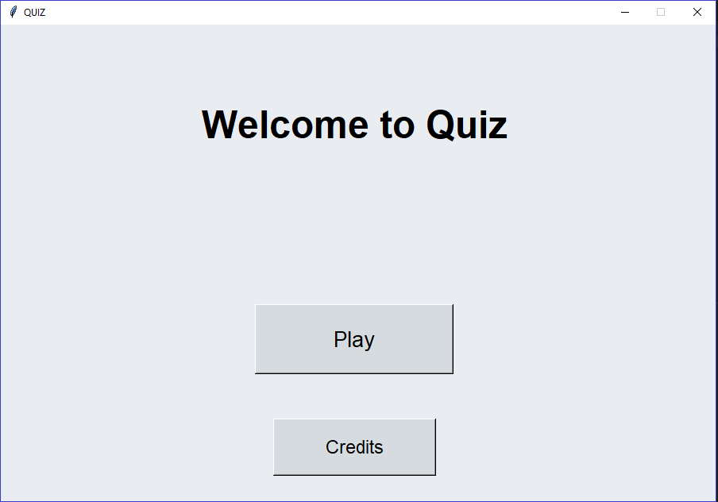
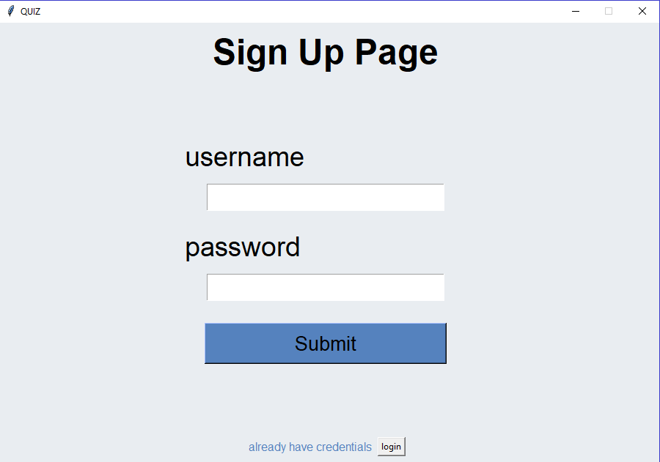

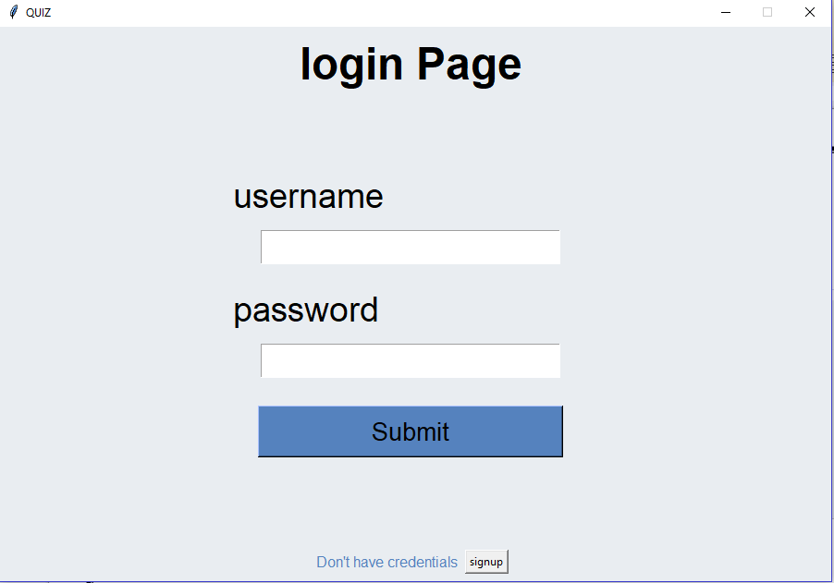
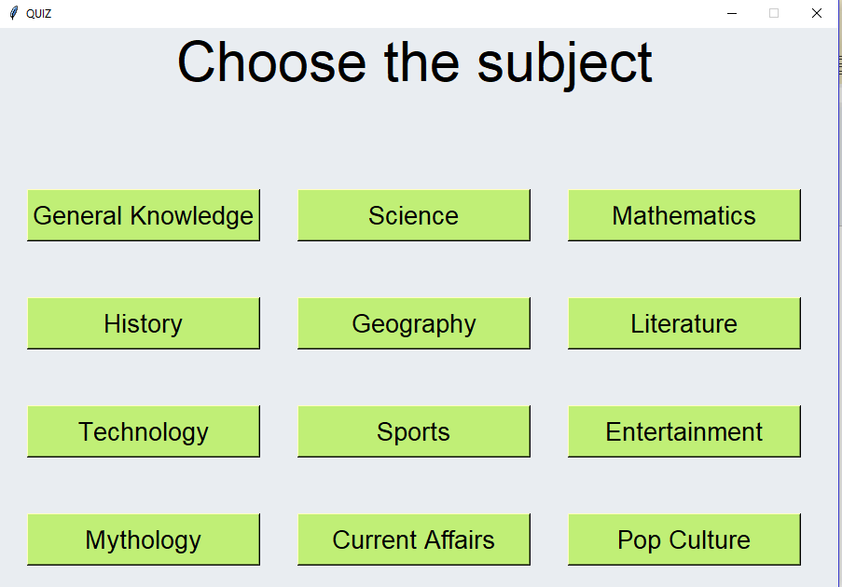

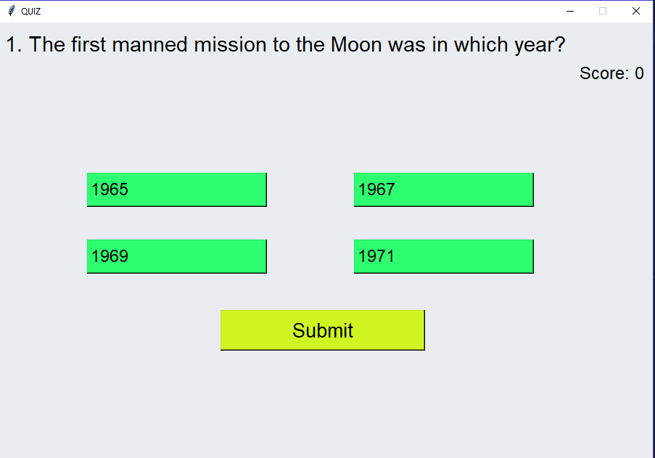
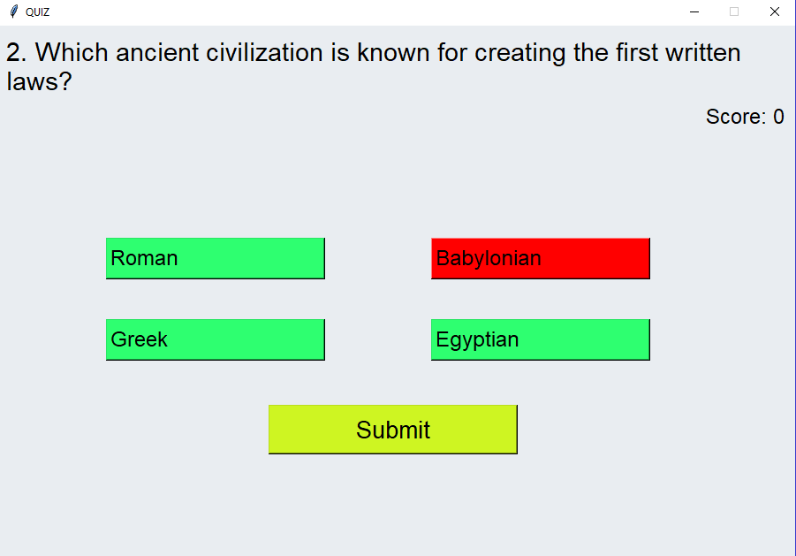

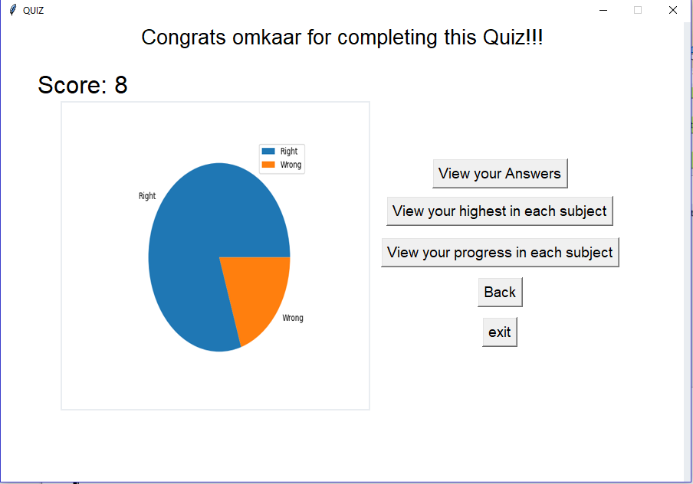
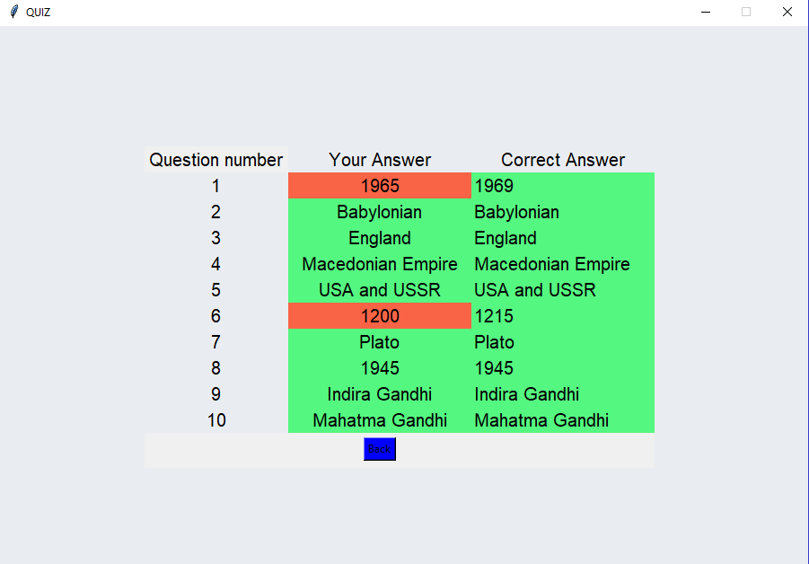

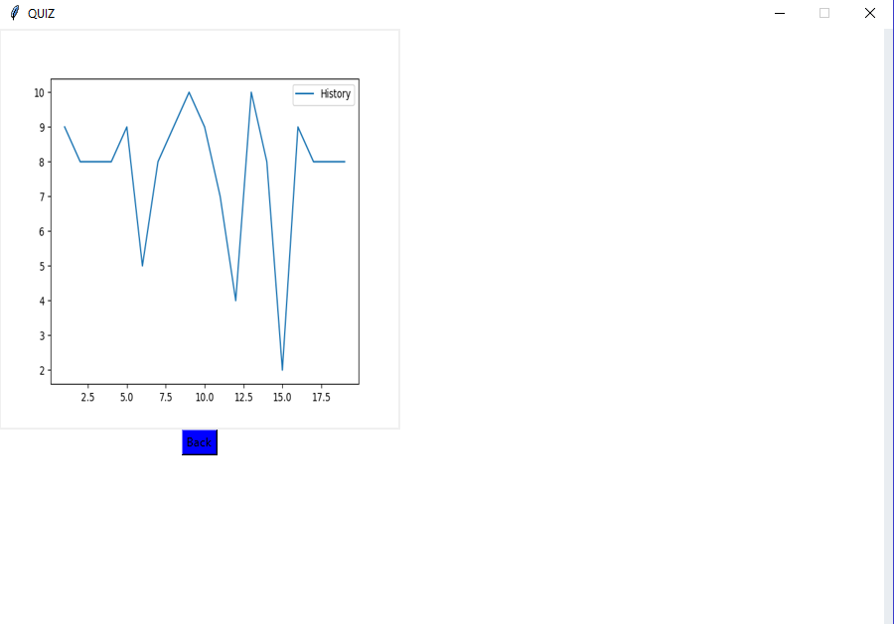
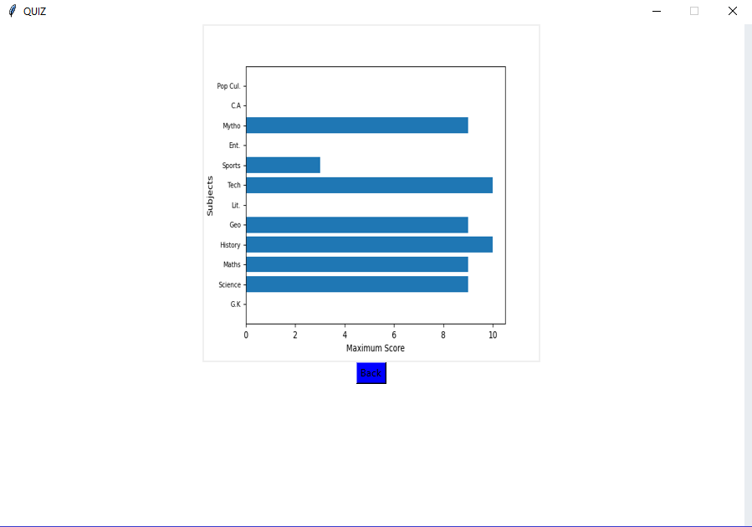

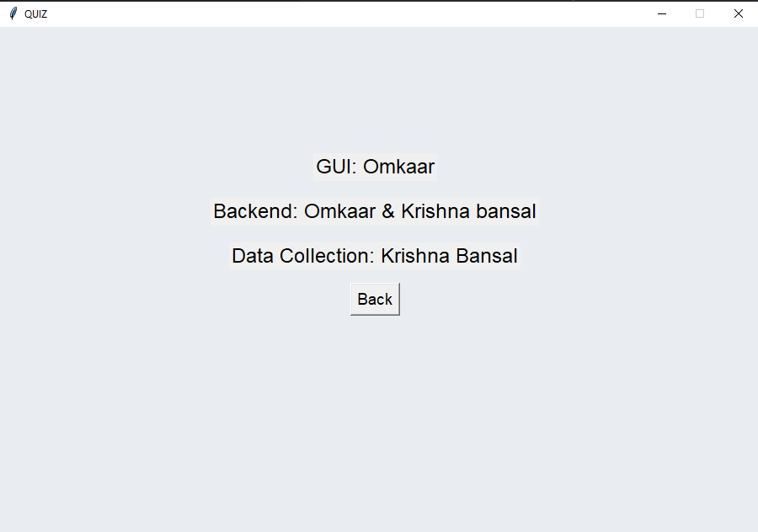

BIBLIOGRAPHY

Books
- Informatics Practices With Python - Class XI By : SumitaArora
- Informatics Practices With Python - Class XII By : SumitaArora
- Informatics Practices With Python - Class XII By : Preeti Arora

Websites
- https://www.dev.mysql.com
- https://www.python.org
- https://www.w3resource.com

***

